
340/380-3800MHz 3 Way 4.3-10F Power Splitter

Part Number | VN-PS-03438-OP3-xxx
Operating Frequency ( MHz ) | 340/380-3800
Impedance ( Ohm ) | 50
VSWR | ≤1.25
Split Loss (dB) | ≤5.6
IM3 (dBc @ 2×43dBm)@xxx | -140 / -150 / -155/ -160/-165
Application | Indoor & Outdoor
Degree of Protection | IP65
Operating Temperature ( ℃ ) | -40 ~ + 80
Interface | 4.3-10 Female
Handling Power (Watt, max) | 500
Peak Power (Watt, max) | 1500
Dimension (mm)(L×W×H, excl connector) | 365×25×25
Net Weight (g) | 645±20
Packing Dimensions (mm,L×W×H) | 420×80×40
Packing Carton Size (mm,L×W×H) | 434×435×195
ROHS Compliance | Yes

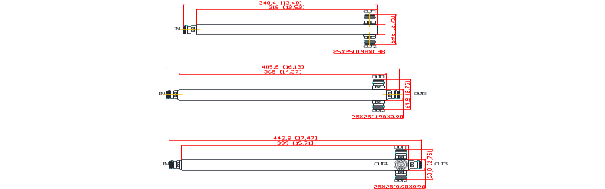
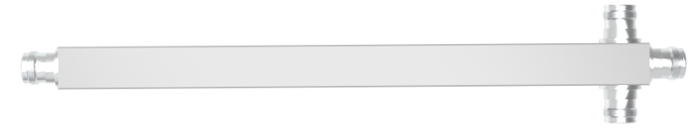

Add：Ganghuai Road, New District Gangji Industrial Zone,Hefei, 231137,China.
Tel：0086-551-65396351 Fax：0086-551-65396352 Web：www.vinncom.com E-mail：sales@vinncom.com

